UC DAVIS ARBORETUM AND PUBLIC GARDEN Learning by Leading Sustainable Horticulture Internship 2018-2019
Commitment: ~3-5 hours/week
Year-long

ABOUT
This is a hands-on full-year internship. This 1 unit internship will meet on Tuesday afternoons from 2-5pm during the fall quarter (Timing will be more flexible during winter and spring quarters). In the fall we will learn essential skills about Sustainable Horticulture, such as tree planting and pruning; garden design and installation; irrigation design and construction; path building; garden maintenance; and more! Leadership and collaboration are also a big part of the program. We will be learning many landscape plants, particularly native California and/or drought tolerant plants for our Central Valley region. The internship is about transforming the campus into a Garden Gateways Campus: Students will have the opportunity to be a part of the design and construction of a garden from scratch during the winter and spring quarters.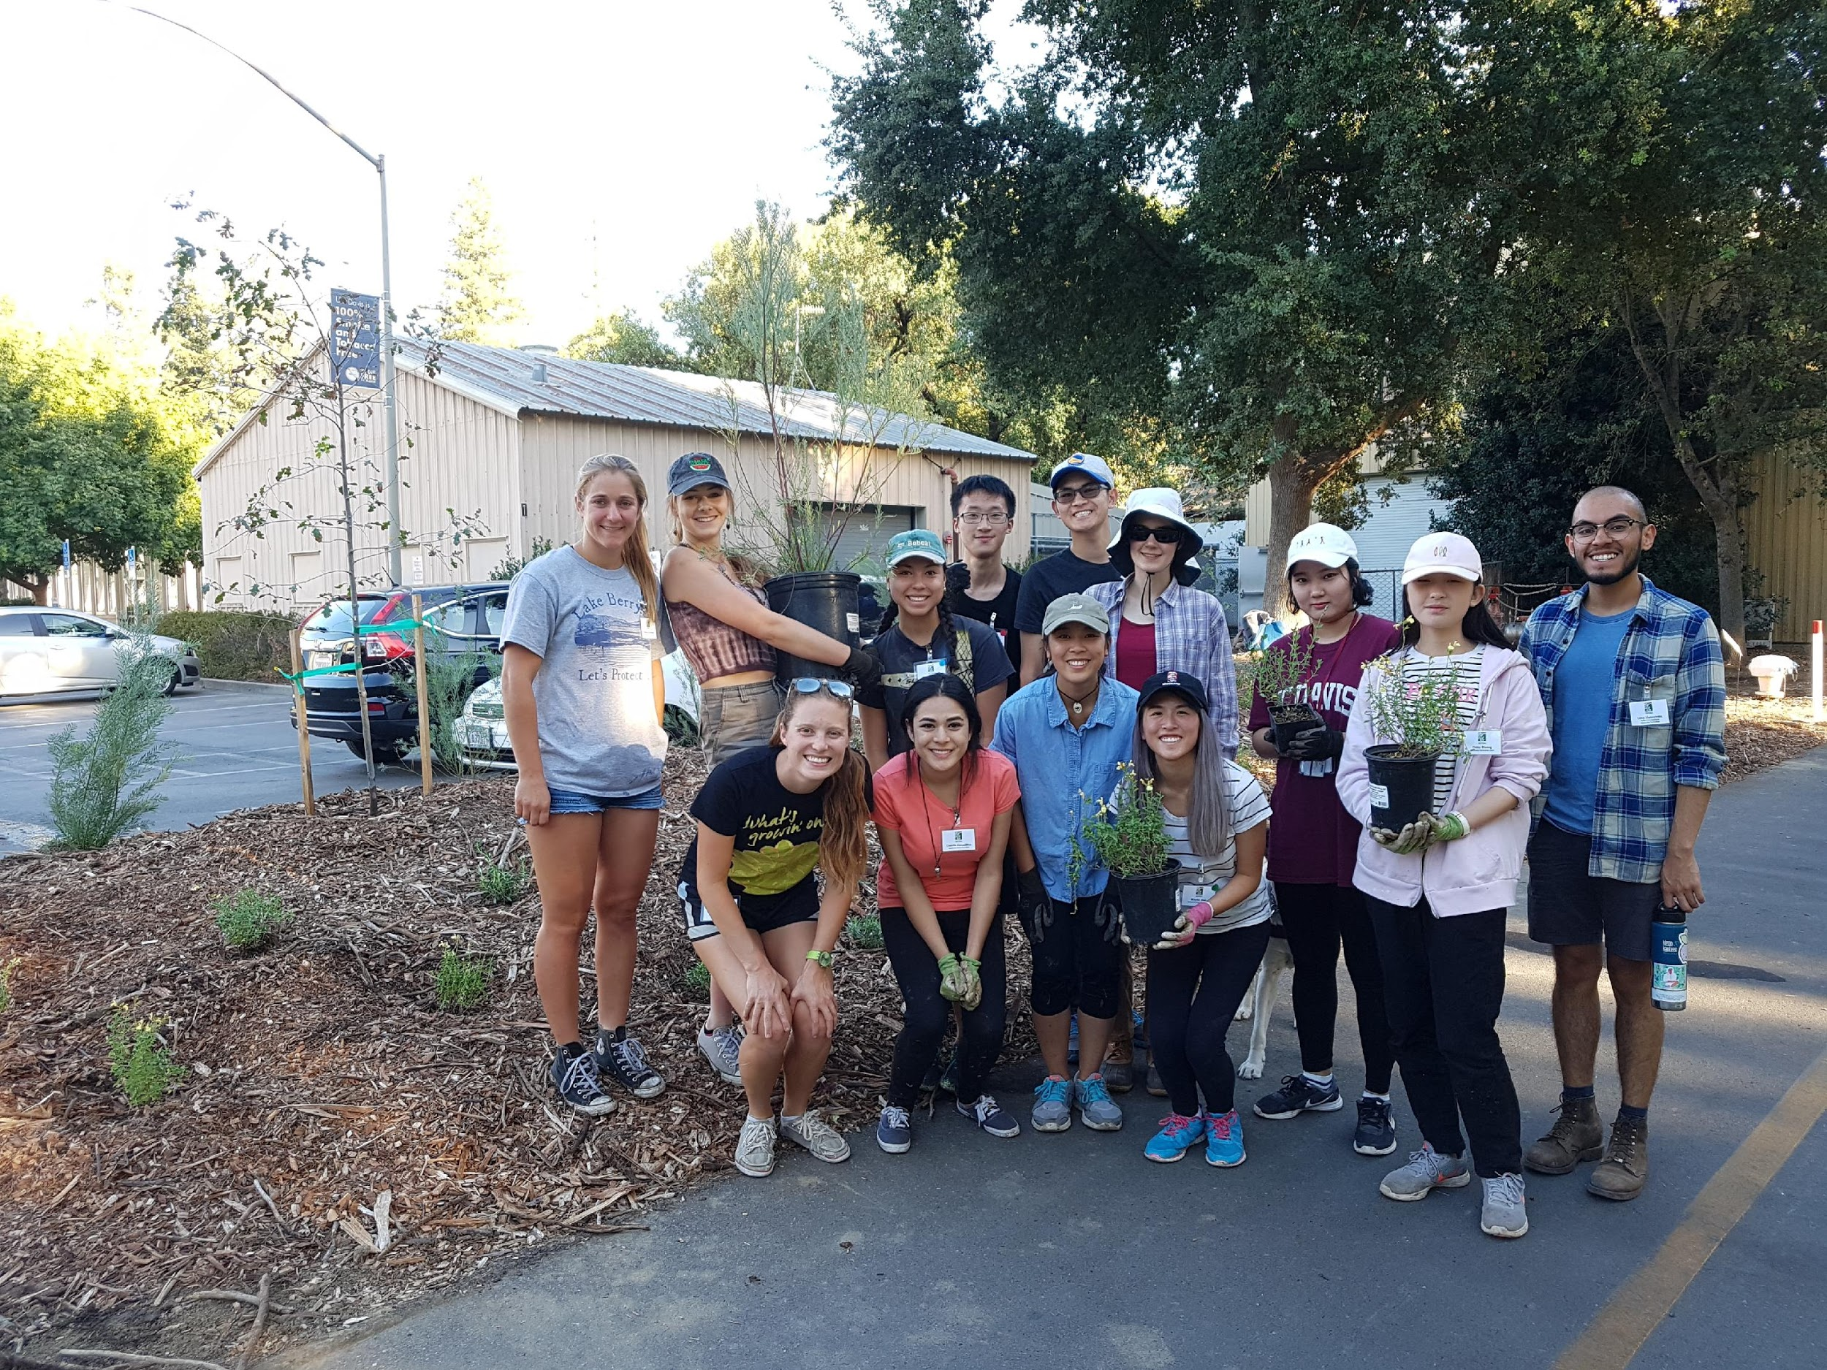
If you are interested in learning more about our program before you apply, check out the Learning by Leading web page (Learning by Leading) and the Sustainable Horticulture web page (Sustainable Horticulture).

Instructor/Mentor: Ryan Deering, UCD Arboretum
Student Co-Coordinators: Kaylin Hui and Katherine Brafford

UC DAVIS ARBORETUM AND PUBLIC GARDEN
INTERNSHIP APPLICATION 2018-2019

INSTRUCTIONS:
Please complete and e-mail your answers back to Ryan Deering (rhdeering@ucdavis.edu). Thoughtful responses are appreciated. Spaces are limited, so please apply as soon as possible.

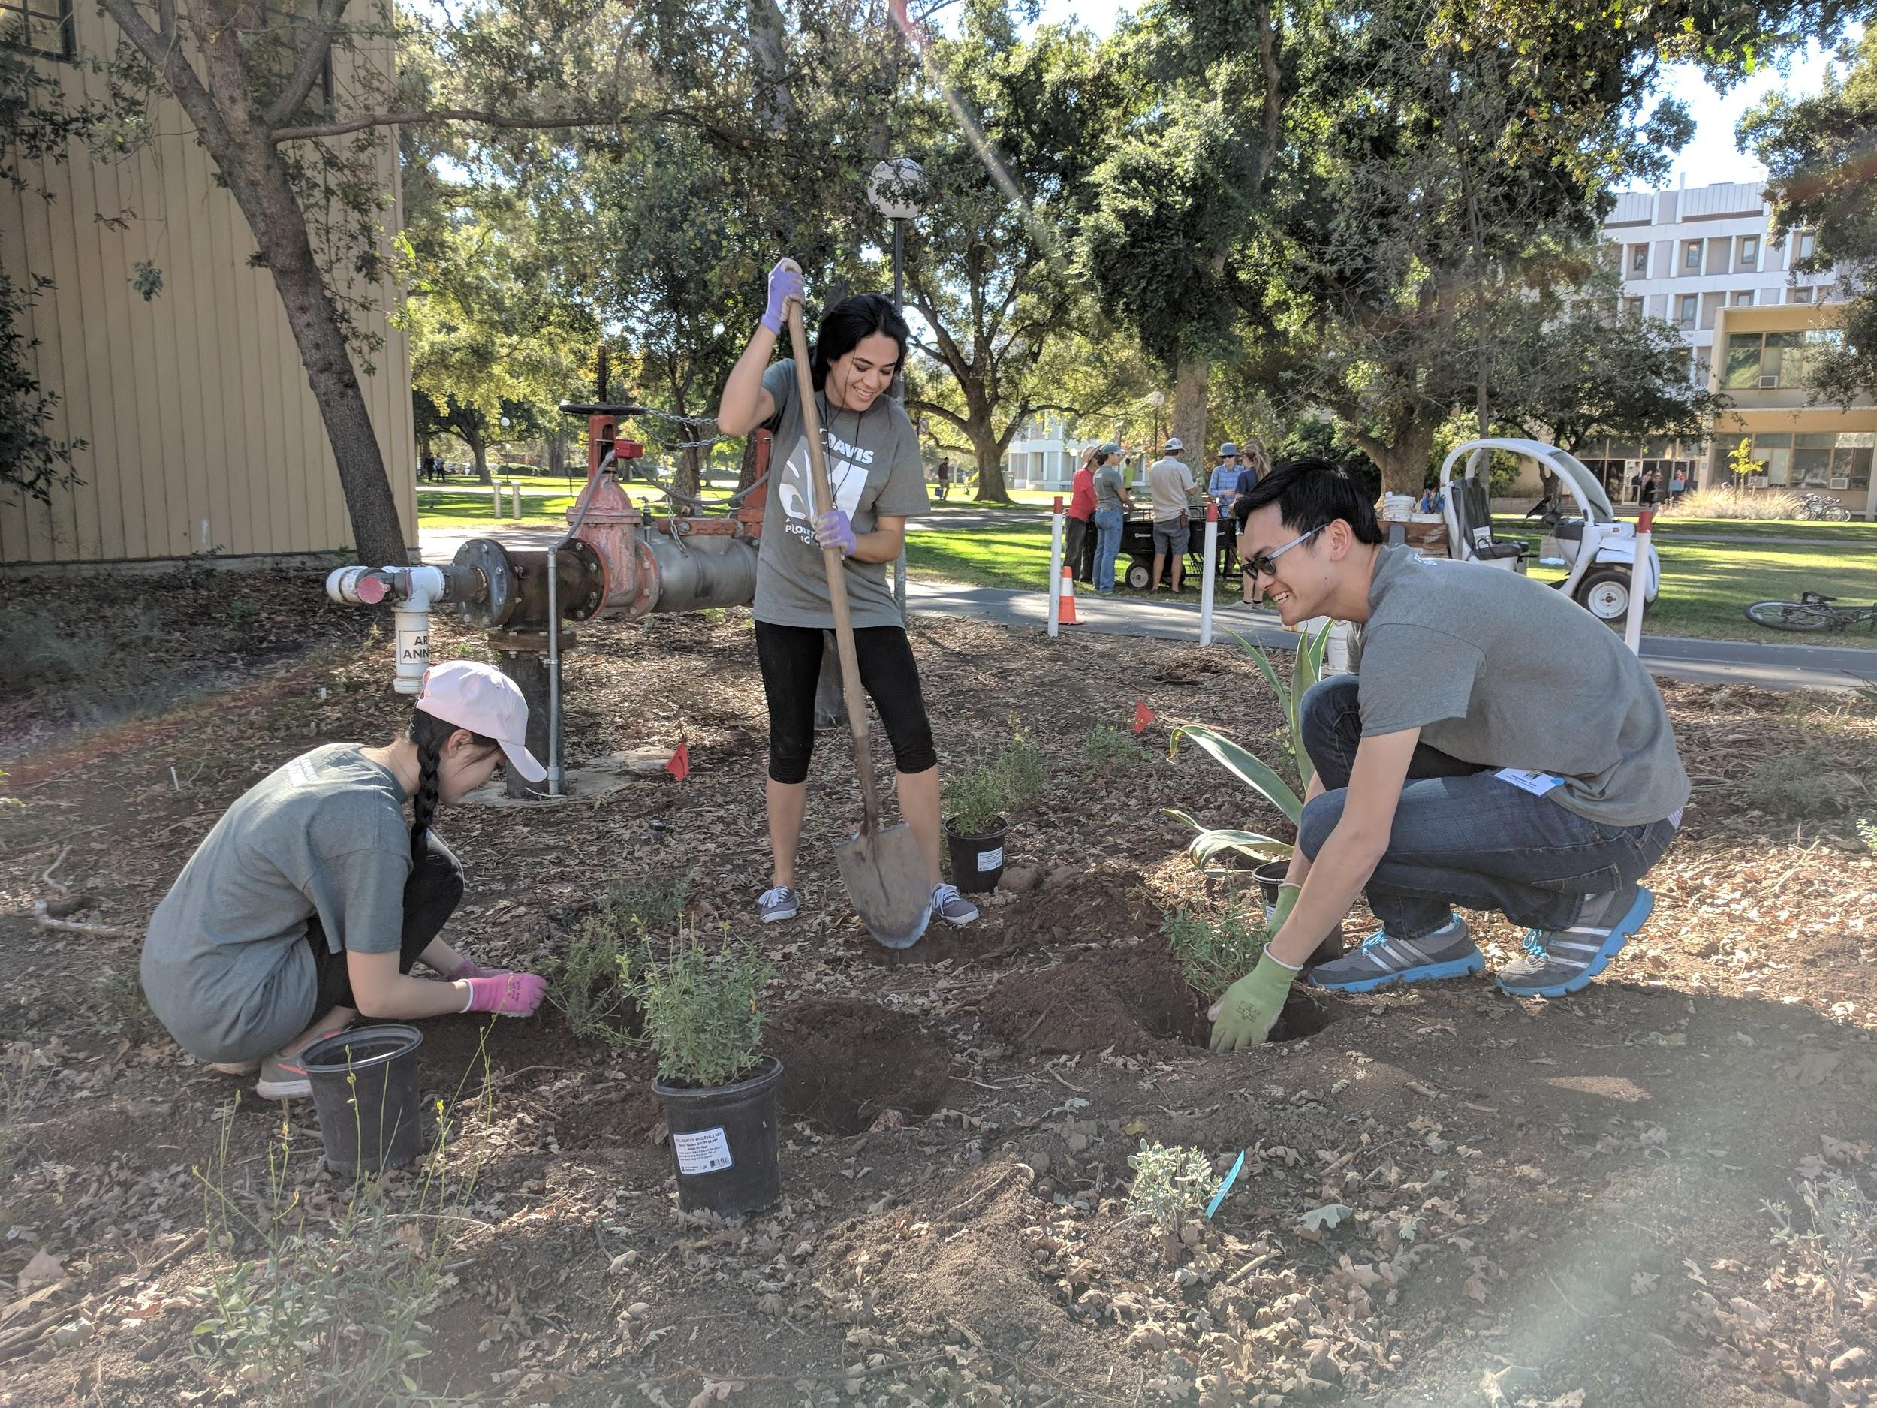
EXTENDED Application Deadline: Friday, September 21 by midnight
Fall Quarter Meeting Time: Every Tuesday from 2 - 5 PM
Applying for:
Learning by Leading Sustainable Horticulture Internship – send to Ryan Deering, rhdeering@ucdavis.edu
Please use this format for your email subject: First and Last name - LxL Hort Internship Application

1. Name:

E-mail:

Phone:

Year at UC Davis:

Major:

2. Please list your Monday - Friday availability for the fall. Are you available to meet on Tuesdays from 2-5 PM during Fall Quarter?

3. Why are you interested in this internship? What do you want to learn or hope to gain?

4. Have you ever worked in a garden or grown plants on your own? Describe in detail please.

5. Have you had prior leadership experience? Describe in detail please.

6. Have you had prior experience with community outreach or development? Please explain.

7. Please list any classes you have taken or experiences you have had relating to identifying or cultivating plants. (Note: Experience with plant identification is not required, but will be helpful.)

8. Why should we choose you? What strengths will you bring to our team?

